**CHAPTER 1**

**INTRODUCTION**

Titan Company Limited, renowned for its luxury fashion accessories, operates four primary business units: Watches & Wearables, Taneira, Tanishq, and Eye Plus. As a forward-thinking organization, Titan recognized the inefficiencies associated with manual data tracking and the pressing need to transition to a digital system to enhance operational efficiency. To address this challenge, the Field Digitalization App was developed, designed to streamline various processes across the company. This sophisticated application encompasses modules for performance tracking, task management, and competition analysis, each tailored to meet the unique needs of Titan’s diverse business units. By digitizing these critical functions, Titan aimed to not only improve the accuracy and speed of data processing but also to empower its workforce with real-time insights and tools for better decision-making.

The focus of my internship was to develop Standard Operating Procedures (SOPs) for the Field Digitalization App, ensuring its consistent and efficient use across the company. This involved a comprehensive understanding of the app’s functionality and its application within different business contexts. Collaborating with various teams, including IT, Project, and UAT Testing, I gathered detailed requirements and feedback to create robust and user-friendly SOPs. These documents serve as a guide to standardize operations, reduce training time, and enhance the overall efficiency of the app. Through this project, I contributed to Titan’s digital transformation journey, ensuring that the new system is effectively integrated into daily operations, ultimately supporting the company’s goals of increased productivity and streamlined processes.

**CHAPTER 2**

**LITERATURE SURVEY**

The Field Digitalization App operates on the Salesforce platform, providing robust solutions for performance tracking, task management, and competition analysis. Key advantages of the system include real-time data access, improved task prioritization, and comprehensive performance metrics. However, challenges such as initial training requirements and system integration complexities were noted. Advanced digitalization systems offer further capabilities such as AI-driven insights and predictive analytics, presenting opportunities for future enhancements.

**CHAPTER 3**

**INTERNSHIP WORK AND DISCUSSION**

**Week 1:**

During the first week, I was introduced to Titan Company Limited and its IT department. This initial phase involved understanding the organizational structure and getting an overview of the Field Digitalization App and its various modules. I attended introductory meetings with key stakeholders from the IT, Project, and UAT Testing teams to grasp the scope of the digitalization project and the specific needs for Standard Operating Procedures (SOPs). This week laid the groundwork for identifying the critical areas where SOPs would be most beneficial.

**Week 2:**

The second week was dedicated to a detailed study of the existing manual processes and identifying inefficiencies that the Field Digitalization App aimed to address. I began developing draft SOPs for crucial processes such as Single Sign-On (SSO) and Multi-Factor Authentication (MFA). This involved understanding the technical aspects of these processes and how they integrate with the app. I also conducted stakeholder feedback sessions to gather input and ensure the SOPs met the requirements of various departments.

**Week 3:**

In the third week, I focused on revising and finalizing the SOPs based on the feedback received. This iterative process included refining the details and ensuring clarity and usability of the documents. I expanded my work to include the creation of business documents for additional processes such as the Global MFA, Reset MFA, Password Policy, Tooltip, Admin Panel and Custom Filter. This week also involved testing the SOPs with the project teams to ensure they were practical and effective in real-world scenarios.

**Week 4:**

The final week was dedicated to compiling all the SOPs and business documents into a comprehensive package. I prepared for and conducted a final presentation of my findings and the developed SOPs to the project team and other stakeholders. This presentation highlighted the significant improvements in efficiency and time savings achieved through the Field Digitalization App. Additionally, I reflected on my internship experience, documenting the key learnings and skills acquired, and provided recommendations for future enhancements to the digitalization project.

**Sample SOP Documentation for Admin Panel**

This SOP outlines the procedures for the Master Admin to manage the admin panel, which includes adding users as admin, assign necessary roles and remove admin as needed.

**Process Overview:**

The Master Admin has the authority to add users as admin, assign necessary roles and remove admin as needed from the admin panel. Here are the step-by-step instructions for these actions:

* **To Add a User as Admin:**

**Step1: Access the Admin Panel:**

- Log in to the system as a Master Admin and access the Admin Panel.

**Step2: Add New User:**

- In the Admin Panel, locate the "Add New User" form.

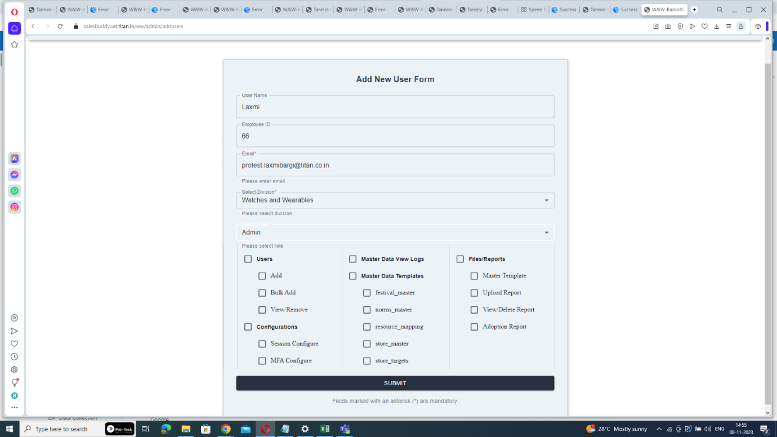

**Step3: Enter User Details:**

- Fill in the new user's details, including their Username, Employee ID, Email, division, and select the role as "Admin".

**Step4: Grant Access to Necessary Roles:**

**-** Assign access to necessary roles by clicking on the corresponding column and click "Submit" to save the user details.



Click here to select only necessary roles

Click here to select all the roles comes under particular section

**Step5: Email notification:  
 -** The user will receive an email with their username and password for login.

**Step6: User Login:**

- The newly added admin can log in using the provided username and password by clicking to the link.

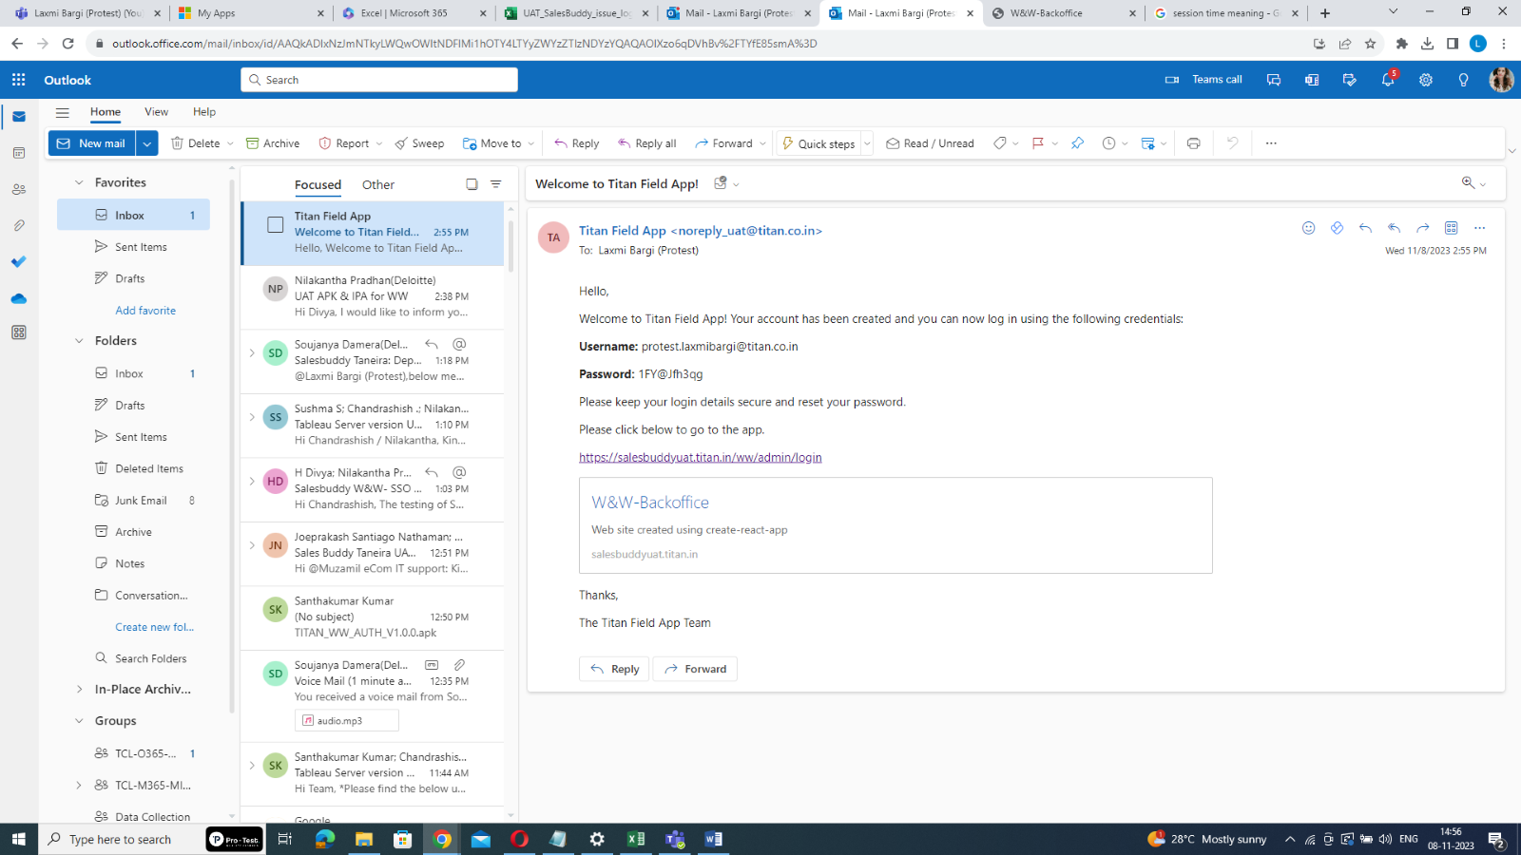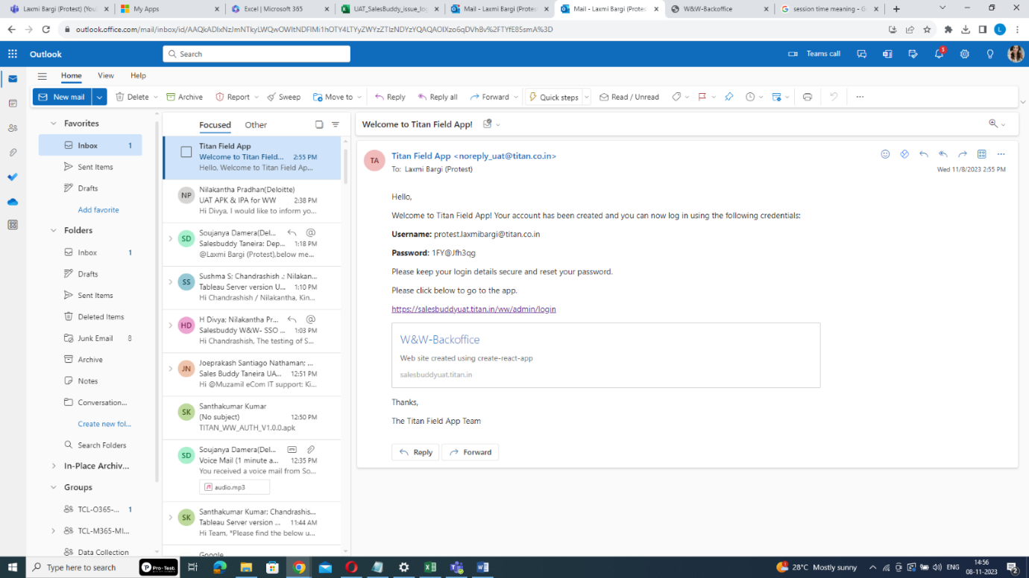

Username and initial password

Link to login

**Step7: Reset the Password:**

- After entering the Username & initial password, click "LOG IN". The system will redirect you to the password reset page. In reset password page, create a new password. Ensure that it meets the following criteria

* 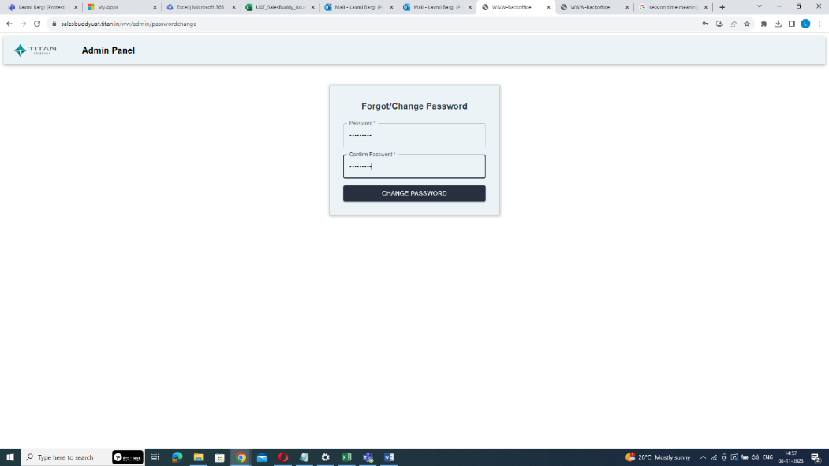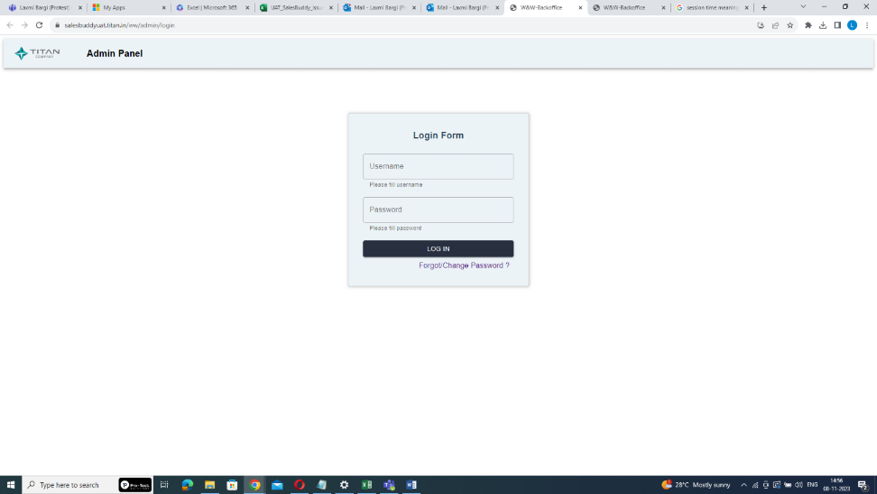Password length must be at least 10 characters.

Create a new password

* At least 1 digit.

Enter username and initial password sent through email

* At least 1 lowercase letter.
* At least 1 uppercase letter.
* At least 1 non-alphanumeric special character.

**Step8: Confirm the Password:**

- Re-enter the newly created password for confirmation & click on “change password” button.

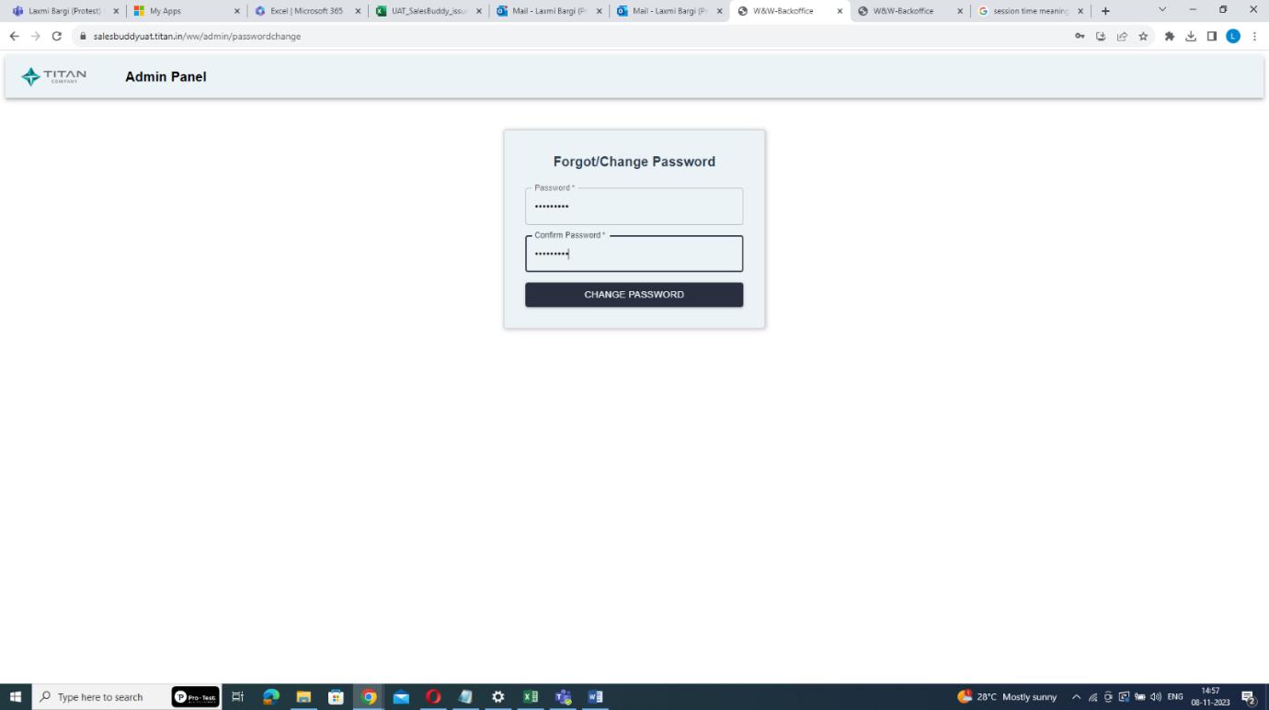

Confirm your password

**Step9: Click on re-login:**

**-** To go back to the login page click “re-login” & Re-login using your email ID and the newly created password.

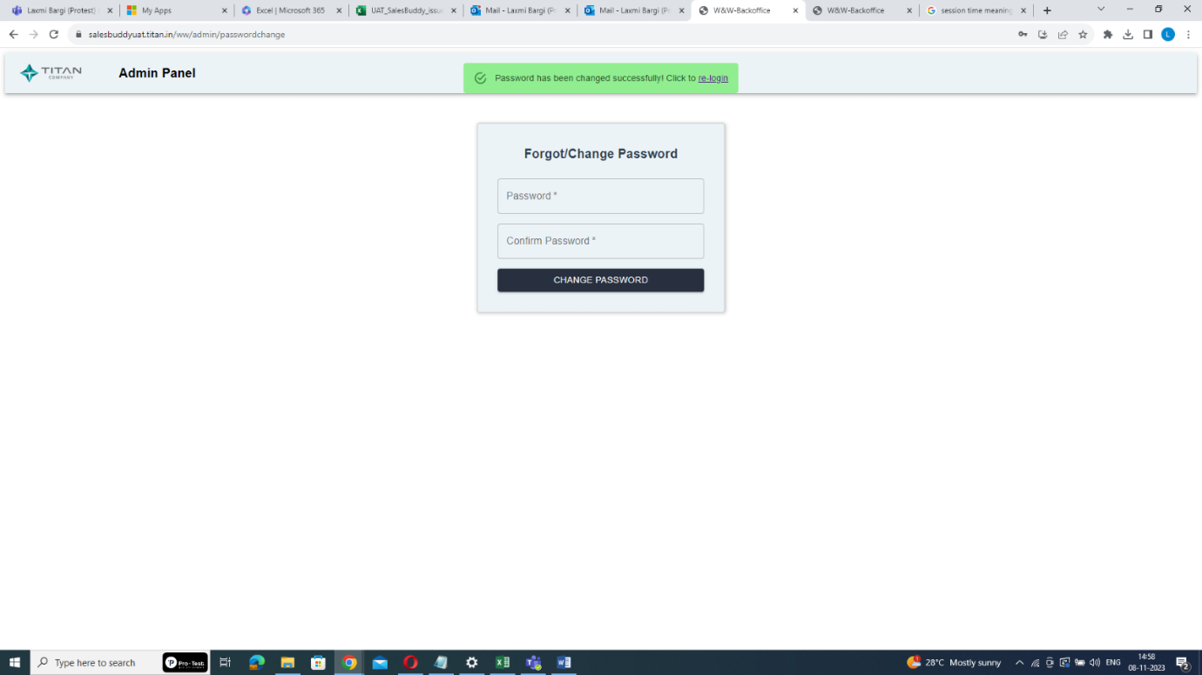

Click here

* **To Update User Roles:**

**Step1: Access the Admin Panel:**

**-** Log in to the system as a Master Admin and access the Admin Panel.

**Step2: Search for the User:**

- Enter the user's email and click "Search".

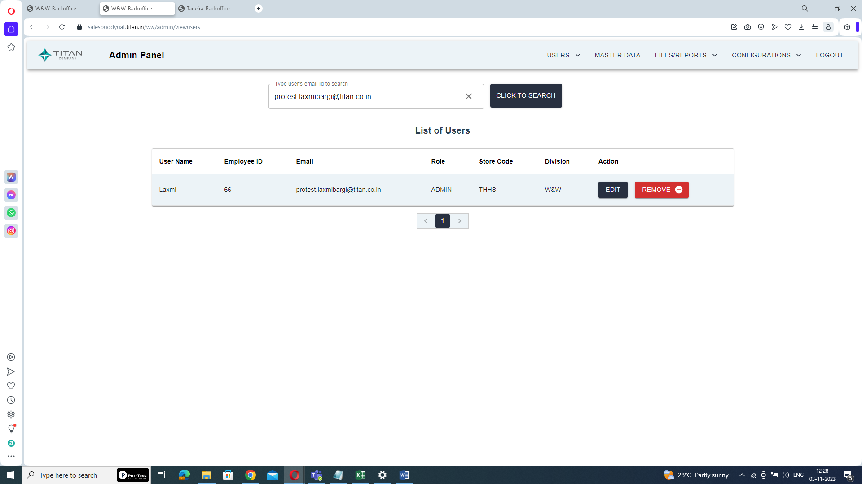

Enter user’s email-id

**Step3: Edit User Roles:**

- Click on the "Edit" button to update the user's roles.



Click on EDIT

**Step4: Add or Remove Access:**

- Modify the user's access by adding or removing necessary roles.

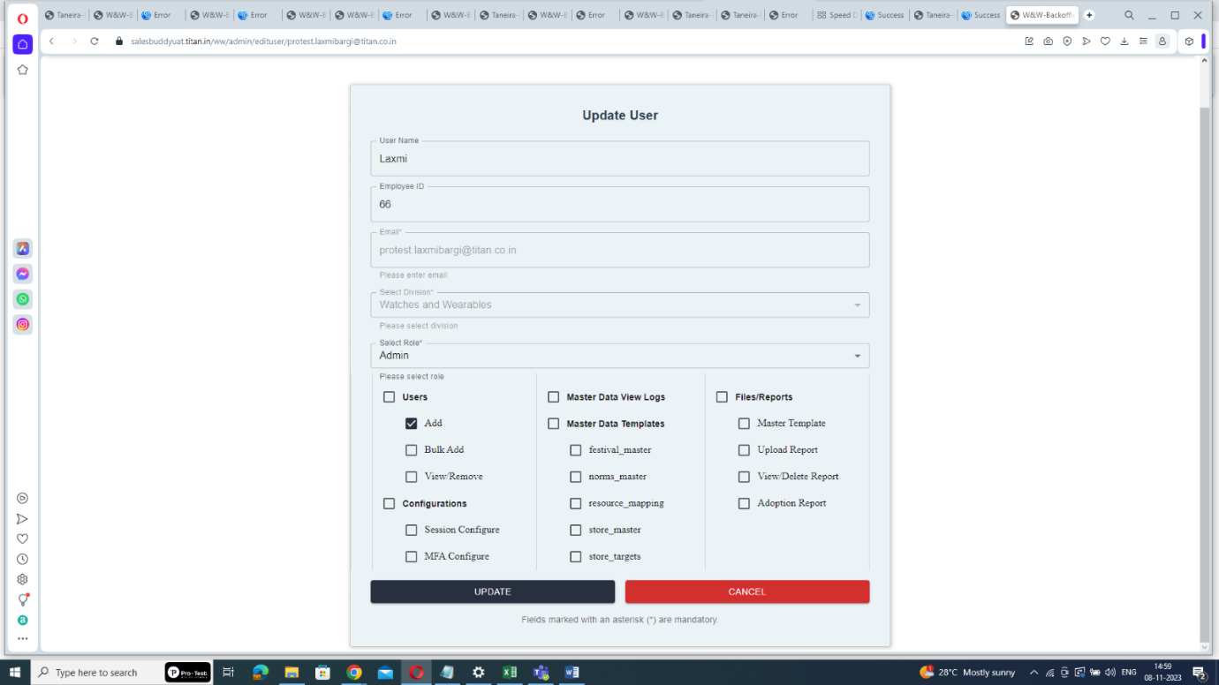

add or remove roles here

**Step5: Submit the Changes:**

- Click "Submit" to save the updated roles,

* **To remove a user:**

**Step1: Access the Admin Panel:**

**-** Log in to the system as a Master Admin and access the Admin Panel.

**Step2: Search for the User:**

- Enter the user's email and click "Search".



Enter user’s email-id

**Step3: Remove the User:**

- Click on the "Remove" button to delete the user as admin.



Click on Remove

By following these steps, the Master Admin can efficiently manage users’s roles within the admin panel, ensuring that users have the appropriate access and responsibilities as required.

**CHAPTER 4**

**CONCLUSION**

The internship at Titan Company Limited provided practical insights into the industry, enriched my understanding of business processes at Titan, and allowed me to contribute meaningfully to the development and implementation of SOPs and business documents in a real-world environment. The creation and implementation of these SOPs significantly streamlined operations, reduced training time, and improved efficiency in data utilization and performance review processes.

From the work carried out and results obtained, it is clear that the digitalization of manual processes has a substantial positive impact on organizational efficiency. However, there is always room for further improvement. Future studies could explore advanced digitalization technologies, such as AI-driven insights and predictive analytics, and their potential to further optimize business processes at Titan. Additionally, continuous feedback and iterative updates to the SOPs will ensure they remain relevant and effective in a rapidly evolving technological landscape.

**BIBLIOGRAPHY**

"Best Practices for SOP Creation." *Tech Solutions Blog*, 2022. www.techsolutionsblog.com/sop-best-practices

Titan Company Limited. (2023). Annual Report 2022-2023. Retrieved from <https://www.titancompany.in/investors/annual-reports>

*Salesforce Documentation*. (2022). Salesforce Inc

"Implementing SOPs in IT Projects: A Case Study," *Proceedings of the International Conference on IT Management*, 2019.